**TUGAS GRAPH**



**Dosen Pengampu :**

**A.A. Gede Yudhi Paramartha, S.Kom., M.Kom.**

**Disusun Oleh :**

**I Gede Gelgel Abdiutama ; 2115101014**

**MATA KULIAH STRUKTUR DATA DAN ALGORITMA**

**UNIVERSITAS PENDIDIKAN GANESHA**

**SINGARAJA**

**2022**

1. **PERMASALAHAN**
2. Make an adjacency list representation of Graph X!
3. Make an adjacency matrix representation of Graph X!
4. Traverse Graph X starting from vertex A using DFT!
5. Traverse Graph X starting from vertex A using BFT!
6. Find the shortest path of Graph X using Dijkstra’s shortest path algorithm starting from vertex A!

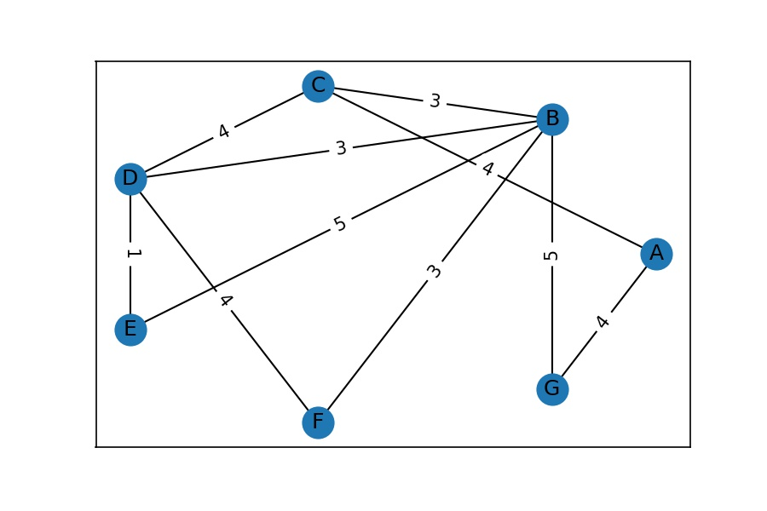

**Graph X**

1. **PENYELESAIAN**
2. Make an adjacency list representation of Graph X!

|  |  |  |  |  |  |  |
| --- | --- | --- | --- | --- | --- | --- |
| A |  | C  W=4 | G  W=4 |  |  |  |
|  |
| B |  | C  W=3 | D  W=3 | E  W=5 | F  W=3 | G  W=5 |
|  |
| C |  | A  W=4 | B  W=3 | D  W=4 |
|  |
| D |  | C  W=4 | B  W=3 | E  W=1 | F  W=4 |
|  |
| E |  | B  W=5 | D  W=1 |
|  |
| F |  | B  W=3 | D  W=4 |
|  |
| G |  | A  W=4 | B  W=5 |

1. Make an adjacency matrix representation of Graph X!

|  |  |  |  |  |  |  |  |
| --- | --- | --- | --- | --- | --- | --- | --- |
|  | **A** | **B** | **C** | **D** | **E** | **F** | **G** |
| **A** |  |  | 4 |  |  |  | 4 |
| **B** |  |  | 3 | 3 | 5 | 3 | 5 |
| **C** | 4 | 3 |  | 4 |  |  |  |
| **D** |  | 3 | 4 |  | 1 | 4 |  |
| **E** |  | 5 |  | 1 |  |  |  |
| **F** |  | 3 |  | 4 |  |  |  |
| **G** | 4 | 5 |  |  |  |  |  |

1. Traverse Graph X starting from vertex A using DFT!

|  |  |  |  |  |  |  |  |  |  |  |
| --- | --- | --- | --- | --- | --- | --- | --- | --- | --- | --- |
| Step1 | Pseudocode |  | Step2 | Pseudocode |  | Step3 | Pseudocode |  | Step4 | Pseudocode |
|  |  |  |  |  |  |  |  |  |  |  |
| F | Push(F) |  |  | Pop(F) |  | G | Push(G) |  |  | Pop(G) |
| B | Push(B) |  | B | - |  | B | - |  |  | Pop(B) |
| E | Push(E) |  | E | - |  | E | - |  |  | Pop(E) |
| D | Push(D) |  | D | - |  | D | - |  |  | Pop(D) |
| C | Push(C) |  | C | - |  | C | - |  |  | Pop(C) |
| A | Push(A) |  | A | - |  | A | - |  |  | Pop(A) |



1. Traverse Graph X starting from vertex A using BFT!

|  |  |  |  |  |  |  |  |
| --- | --- | --- | --- | --- | --- | --- | --- |
| Step1(Visit A) | A | C | G |  |  |  |  |
| Pseudocode | En(A) | En(C) | En(B) |  |  |  |  |
|  |  |  |  |  |  |  |  |
| Step2(Visit C) |  | C | G | B | D |  |  |
| Pseudocode | De(A) | - | - | En(B) | En(D) |  |  |
|  |  |  |  |  |  |  |  |
| Step3(Visit G) |  |  | G | B | D |  |  |
| Pseudocode | - | De(C) | - | - | - |  |  |
|  |  |  |  |  |  |  |  |
| Step4(Visit B) |  |  |  | B | D | F | E |
| Pseudocode | - | - | De(G) | - | - | En(F) | En(E) |
|  |  |  |  |  |  |  |  |
| Step5(Visit D) |  |  |  |  | D | F | E |
| Pseudocode | - | - | - | De(B) | - | - | - |
|  |  |  |  |  |  |  |  |
| Step6(Visit F) |  |  |  |  |  | F | E |
| Pseudocode | - | - | - | - | De(D) | - | - |
|  |  |  |  |  |  |  |  |
| Step7(Visit E) |  |  |  |  |  |  | E |
| Pseudocode | - | - | - | - | - | De(F) | - |
|  |  |  |  |  |  |  |  |
| Step8(Finish) |  |  |  |  |  |  |  |
| Pseudocode | - | - | - | - | - | - | - |
|  |  |  |  |  |  |  |  |



1. Find the shortest path of Graph X using Dijkstra’s shortest path algorithm starting from vertex A!



|  |  |  |
| --- | --- | --- |
| Vertex | Shortest distance from A | Previous vertex |
| A | 0 |  |
| B | 7 | C |
| C | 4 | A |
| D | 8 | C |
| E | 9 | D |
| F | 10 | B |
| G | 4 | A |

